ME341A – Heat and Mass Transfer

**EXPERIMENT 3**

**CALIBERATION OF THERMOCOUPLES**

**Date: 23 / 01 / 2018**



Department of Mechanical Engineering

Indian Institute of Technology Kanpur

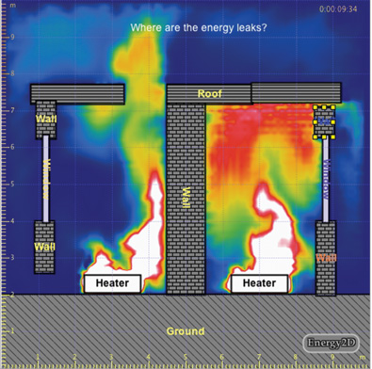

**Group – G1 (a)**

**Members:**

AVINASH KUMAR – 150169

ANUTOSH NIMESH – 150125

SHIKHAR SHIVRAJ JAISWAL – 150670

**OBJECTIVE:**

To calibrate the thermocouple

**EXPERIMENTAL PROCEDURE:**

1. Set the silicone oil bath temperature at a specified temperature greater than ambient temperature.

2. Switch on the heater of silicone oil bath.

3. Monitor the mercury thermometer reading every ten minutes till steady state is attained.

4. Note the value of e. m. f (mV) of the thermocouples T1.

5. Repeat the procedure for silicone oil bath temperatures at different temperatures.

**RESULTS AND DISCUSSION:**

Tamb = 22 oC

Bath liquid = silicon

Material of thermocouple = iron and constantan

|  |  |  |  |  |  |
| --- | --- | --- | --- | --- | --- |
| **S N** | **Set temperature**  **oC** | **Bath temperature T**  **oC** | **T - Tamb**  **oC** | **Emf**  **mV** | **Emf from chart E22-T (mV)** |
| 1 | 75 | 75 | 53 | 2.43 | 2.848 |
| 2 | 80 | 82 | 60 | 2.83 | 3.171 |
| 3 | 90 | 91 | 69 | 3.23 | 3.658 |
| 4 | 95 | 94 | 72 | 3.52 | 3.82 |
| 5 | 100 | 99 | 77 | 3.65 | 4.091 |
| 6 | 105 | 106 | 84 | 3.99 | 4.472 |
| 7 | 110 | 112 | 90 | 4.18 | 4.799 |
| 8 | 115 | 117 | 95 | 4.41 | 5.073 |
| 9 | 120 | 119 | 97 | 4.56 | 5.182 |
| 10 | 125 | 123 | 101 | 4.75 | 5.401 |

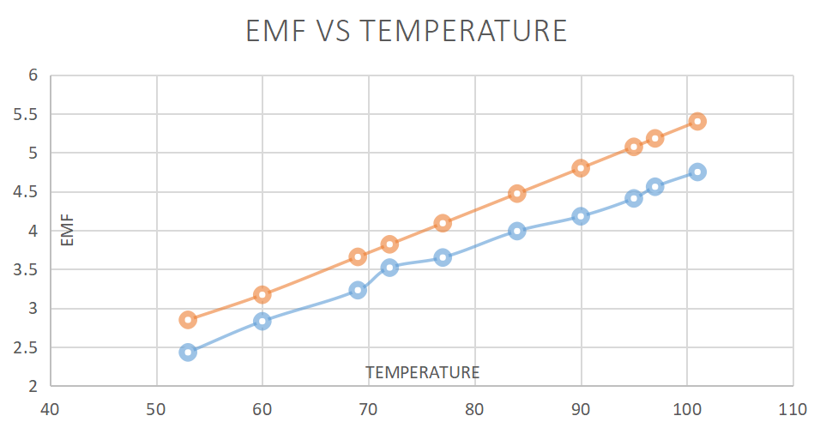

EMF_CHART EMF_EXPERIMENT

J

**DISCUSSIONS AND CONCLUSIONS:**

We observe from the graph that experimental and theoretical values are not consistent, thus showing erroneous results. Sources of such error are:

The slight distortions in measurements are result of some possible error such as parallax error, error in multimeter reading, faulty thermometer, non-uniform distribution of temperature in silicone oil. Thermocouple may not be completely dipped in the bath. After heater is off that is when the desired temperature is reached, we should wait for temperature to get steady and become uniform throughout. Thus showing source of error.

**APPENDIX:**

**Sample Calculation:**

The chart of thermocouple is calibrated with respect to 0 oC. But here ambient is 22 oC, so we need to calibrate it.

From the chart, we first calculate E0-22 = 1.122 mV

Now,

E0-T = E0-22 + E22-T

For any temperature T

So E22-T can be calculated.

For T = 99 oC

E0-T = 5.31 mV

E0-22 = 1.122 mV

E22-T = E0-T -- E0-22 = 5.31 – 1.122 = 4.091 mV

**PRECAUTIONS:**

1. Make sure that the thermocouples beads are properly made.

2. Ensure that there is no any loose connection in the experimental setup.

3. Thermocouples bead, inside the silicone oil bath should not come to the contact.

4. Turn off the multimeter after taking readings in mV

**REFERENCES:**

1) Cengel, Y.A., Heat transfer a practical approach, McGraw Hill publication.

2) Heat and Mass Transfer lab manual

3) Sukhatme, Dr. S.P., A textbook of Heat Transfer, Universities Press

4) Holman, J.P., Heat transfer, McGraw Hill publication

5) Incropera, F.P., and Dewitt, D. P., Fundamentals of Heat and Mass Transfer, John Wiley & Sons, Inc.

6) https://www.engineeringtoolbox.com/